Rev. 11/21/2025
Estimated Project Cost: $14,000,000


LOCATION:
Adjacent to Aransas Bay, between Rockport and Fulton

STATUS:
Testing, Engineering and Design

STAKEHOLDERS:
- Aransas County Navigation District
- Aransas County
- City of Rockport
- General Land Office

ACTIONS:
- Water flow
- Erosion
- Ecosystem for sea life, birds, and terrestrial species
- Ecotourism Drive

PROJECT TYPE:
Tier 1 - Shoreline Stabilization, Habitat Creation, Restoration of Hydrologic Connectivity

ABILITY TO ADDRESS VULNERABILITIES

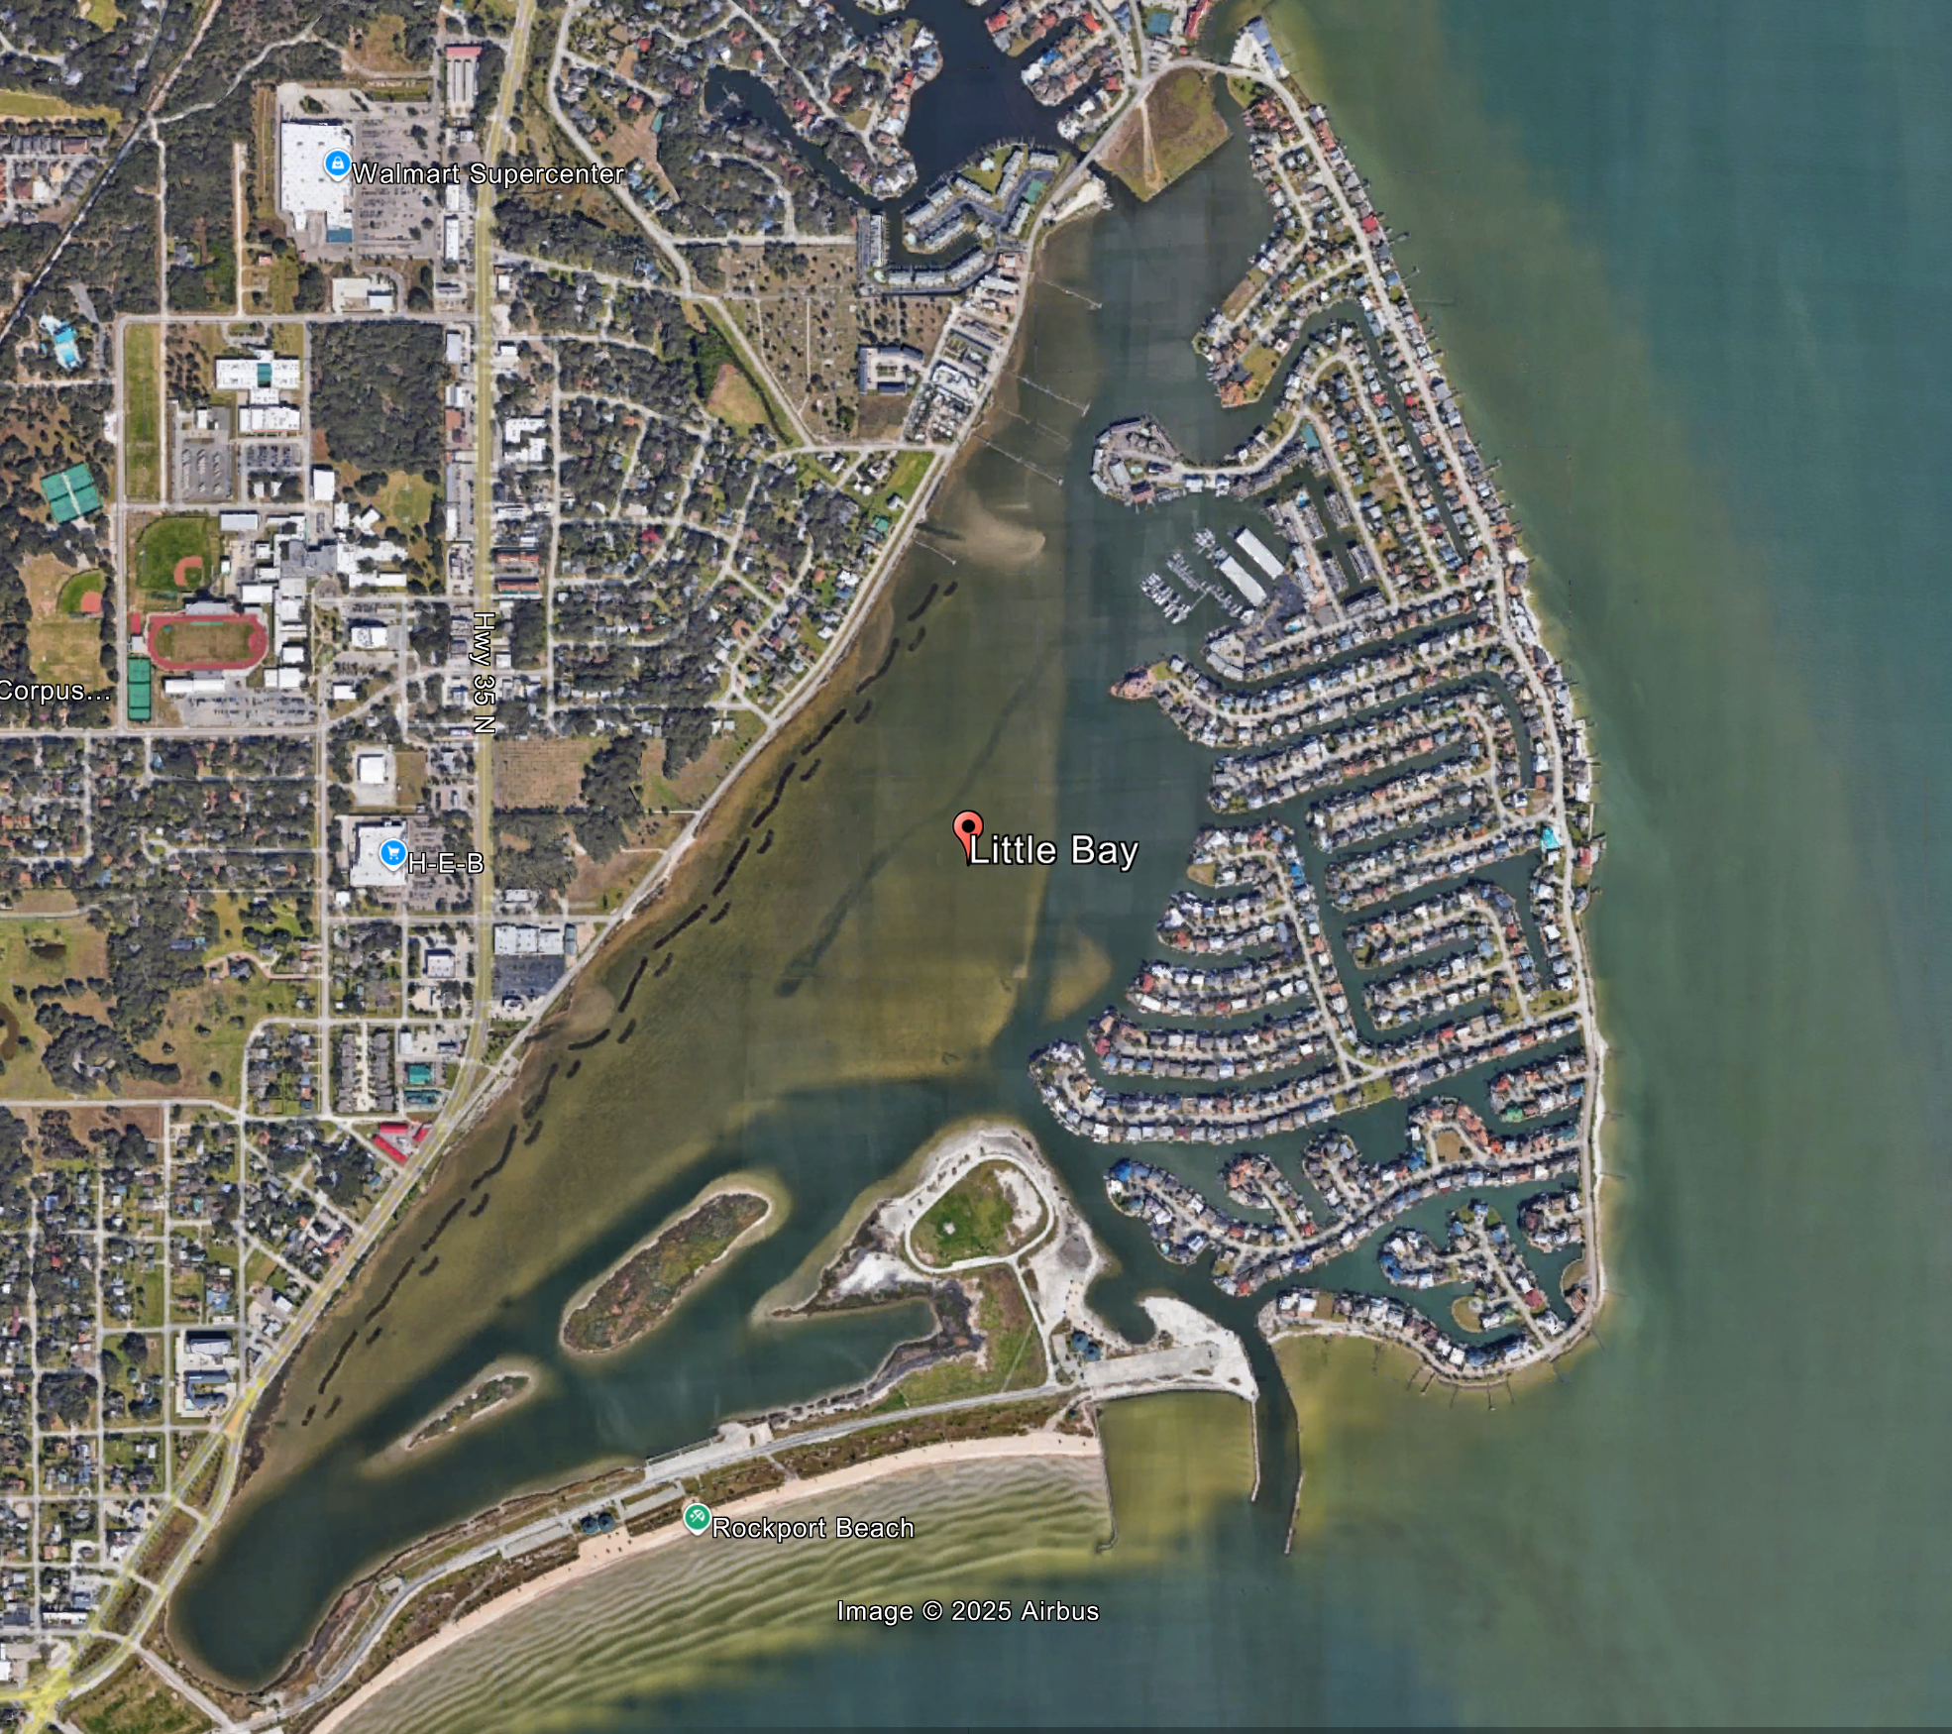

Project Description:
This project would improve water quality in Little Bay, a shallow enclosed bay with approximately 420 acres of surface area and return it to its natural vegetative state. The project would include four tasks to address these issues:
- Evaluate, select, and implement Best Management Practices to reduce impacts due to point source and non-point source inflows – such as re-routing of and/or treatment of inflows, landscape modifications, and other actions to cost-effectively improve water quality.
- Evaluate, select, and implement circulation improvements to enhance water quality, including widening and deepening existing channels and creating new circulation inlets to Rockport Harbor or other similar projects.
- Construct a living shoreline to provide new marsh habitat and protect critical infrastructure from erosion occurring along Broadway Street, which provides bay access to fishermen, bird watchers, tourists, and ecotourists.
- Evaluate and implement plans for beneficial use of dredged material to construct the living shoreline and to restore and stabilize two eroded rookery islands.

Project Need: This effort would help alleviate nuisance and algal blooms, bacterial concerns, and water quality issues that threaten the local tourism-driven economy. It would also make Little Bay better able to sustain and enrich an ecosystem that provides habitat for oyster reefs, wetlands, and seagrasses, as well as local wildlife, coastal migratory birds, fish, crustaceans, and terrestrial and aquatic fauna.

